

Rendered Image

Rendered Image

The purpose of a website is to present or share information online.

Some websites are used to sell stuff online without having contact with the customer like buying stuff off amazon or eBay and the products being posted to your house or maybe collect them at your local store.

Some websites are live news which tell you what is happening in the world at this current time.

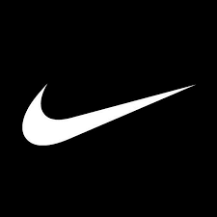The 2 websites I will be comparing are:

Nike: <https://www.nike.com/gb/>

Adidas: <https://www.adidas.co.uk/>

The two websites I will be talking and comparing will be Nike and Adidas and these websites are very much similar and are both targeted to sell sportswear.

Nike is one of the largest and best recognised global sports and athleticwear brands. Its extensive line-up includes its long running air Jordan, air force and much more. Nike is very much known for its celebrity endorsement deals with top athletes, including Tiger Woods, Serena Williams and much more. The company has stayed relevant with consumers over the years through its savvy marketing, which includes embracing controversial topics. Since 2020, Nike has been led by president and CEO John Donahoe, but cofounder and long-time CEO Phil Knight remains active in the company, serving as Chair emeritus.

On the other hand, Adidas has started in a washroom and conquered the world. And in between, Adidas has done their best for the best. Adidas has improved and grown. They are looking ahead to the future, always remembering where they have come from. In 1900 Adidas has first started in a small town in Bavaria, Germany. In the 2000s, the new century has started, adidas reinvented the game again. In addition to its sport performance offering, Adidas is the first in the industry to introduce a new lifestyle segment, focusing on sports-inspired streetwear. Adidas has stated that in the years to come, new partnerships with Yohji Yamamoto and Stella McCartney were born along with exciting labels such as Y-3 and Porsche design sport.

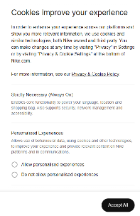**Cookies:**

With the Nike website when you press into it, the privacy policy comes up as soon as you enter the website, and you need to tick boxes. With the Nike website you cannot leave the private policy without ticking the boxes to accept their policy. The purpose of Nike having a cookie policy is to track their customers’ usage of the platform and to understand their customers’ preferences. This would include things like country and language choices. This helps Nike provide the best service to their customers meaning it will improve their online experience.

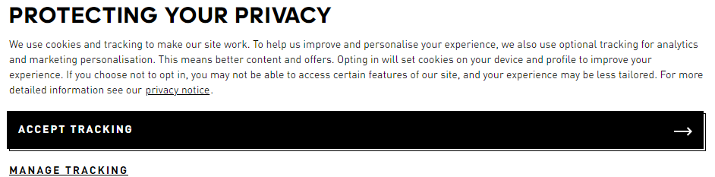The Adidas website also have a privacy policy as soon as you go into their website but there is a difference between the two as the Nike policy has a lot more information meaning that most customers would read it whereas the adidas website has very little information unless you press manage tracking and a customer will most likely just press accept tracking and move on without thinking about it. The website Adidas uses cookies primarily to ensure that your visit to our website is as pleasant as possible. In the Adidas website, below there is an overview of the type of cookies we are using, these are essential in order to enable to move around the website and use its features.

**Target audience:**

**Nike Target Audience:** Nike company caters both men and women athletes equally and they age between 10-40 years of age.

Nike is placing an increase focus on teens to build long term brand loyalty.

Nike's promotion strategy is focused on creating strong, emotional connections with their customers through advertising, sponsorships, and events. They use a variety of marketing channels, such as television, social media, and influencer marketing, to reach their target audience and build brand awareness.

Nike uses the 4p’s when it comes to marketing. These are price, place, promotion and product. By a good mix of these elements, Nike can attract more potential customers which will lead to more sales.

**Purpose of Nike:** The purpose of a Nike website is to move through the power of sport and to bring inspiration and innovation to every athlete in the world.

**Adidas Target Audience:** Target audience for Adidas is typically sports enthusiasts, amateur athletes and professional athletes, who train sport or play on a regular basis. The brand also appeals to those who view sport and fitness as part of their lifestyle and self-image.

This company has a combination of owned retail stores, e-commerce platforms, and third-party retail partnerships, providing a solid distribution network to reach its customers. Adidas has also built a strong presence on social media and collaborates with several various celebrities and sports icons to promote its products.

**Purpose of Adidas:** the purpose of the adidas website is to increase the brand credibility, elevating the experience for our consumer, and pushing the boundaries in sustainability.

The function of the Adidas website is online shopping, and the functionality is whether it serves its purpose or not. The functionality is great because the site not only allows you to place orders to purchase the many products available, but it informs you greatly about the products you are looking at.

**Website Layout:**

**Nike:** The website Nike includes a Nike sign banner and a small row of heading where if you click on it, you can see different headings and there is also advertising with a video of the latest product that is out and this video takes up most of the Nike homepage. When you scroll to the bottom of the homepage you can contact the Nike customer service.

**Adidas:** the adidas website has similar things on the homepage, there is a table at the bottom that if you click into you can enter different products and instead of having a video on the homepage, Adidas has a photo with the newest clothes out.

**User Friendly:**

**Nike:** The Nike website is user friendly as it includes the interactive click buttons at the top where when you click and select either men, women, or kids and then you can search for any categories you want. It also has a search button to search whatever the person needs.

**Adidas:** The Adidas website also have a drop-down list of different categories and has a search bar at the top with the latest trend and the newest products out.

**Consistency:**

**Nike:** The page layout of Nike is very clean as it has a search bar, a drop-down list where if you hover over or click on the different categories and go into different products but also it has a huge video showing the latest products out and when you scroll down you will find the most popular products and the newest products with their prices for easy access. The Nike website has also interactive social media buttons so when you click them, it will open to their page.

**Adidas:** Adidas is very similar to the layout of Nike as it also has a drop-down list with all the categories, a search bar, and the latest shoes out. At the bottom of the page you have newest products, products that are coming soon and the popular products. Adidas also has different social media platforms that are linked to their official website.

**Navigation:**

**Nike:** The Nike website has easy access to people as they have the search bar to look up any products you would be interested in buying, you have the drop-down list with all the categories and the most important, in the corner of the screen you will find the logo and when you click into it you can contact the Nike team member if you have any queries

**Adidas:** Adidas has the same layout to Nike only Adidas has a feedback button at the right-hand side of the screen, and you can give feedback on your recent shop. Adidas collect this data and they will try to improve their service to make it as much suitable as possible.

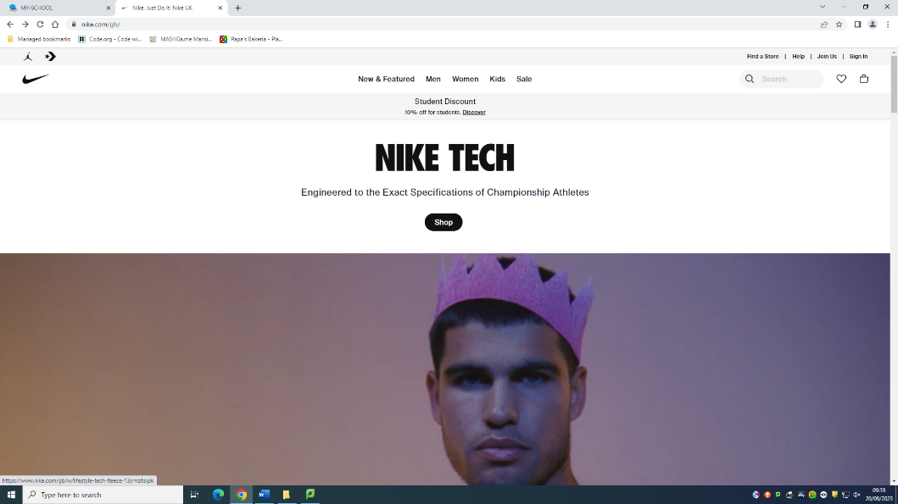**Screenshot:**

**This website is content based for 2.0 web because:**

Nike would be a 2.0 website as it is: Interactive website as you can use the search bar, but also there is a video on the main page of the newest product out.

But also, at the very top and at the very bottom, you can get in contact with Nike if there is something wrong and you can also leave feedback regarding your recent shop weather it was instore or online.

This is where the customers can search for their products.

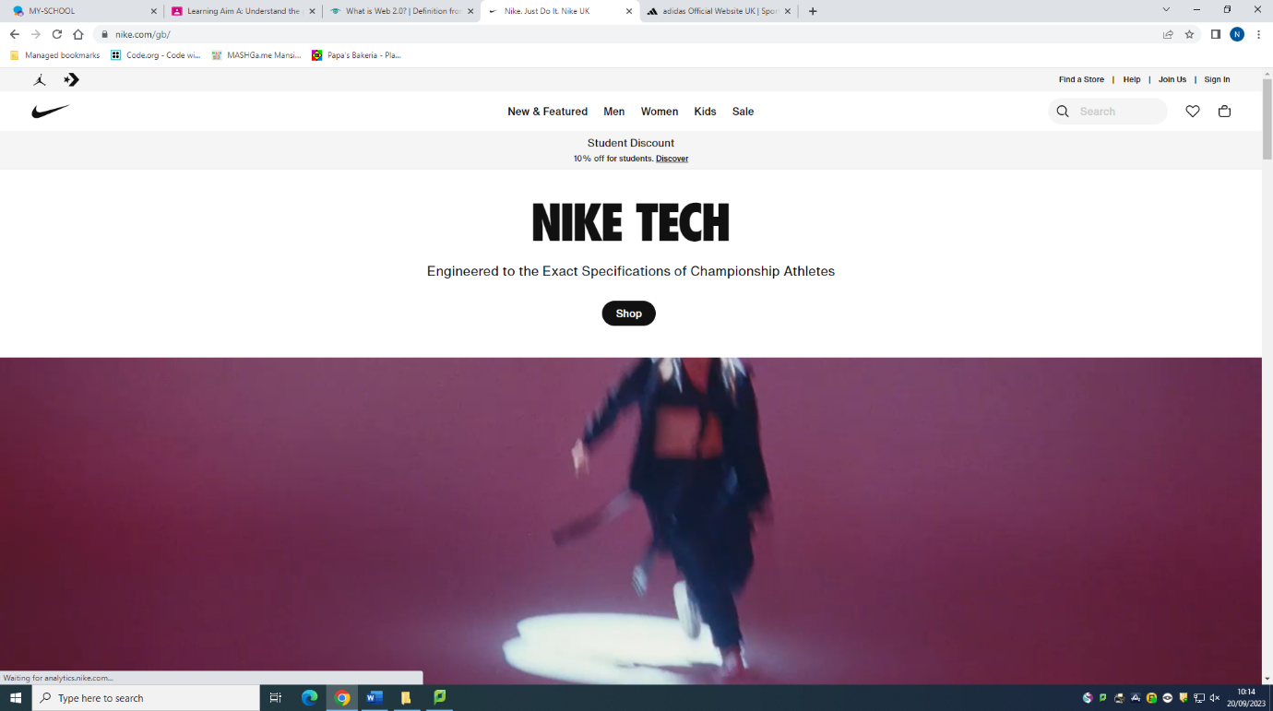

**This website is content based 2.0 web because:**

Adidas also has similar interactive features on their website such as:

A search bar at the top, they also have a bug image of Nike original shoes and when you click the button it will take you to the different type of Adidas originals they have.

Adidas also has a feedback button at the right-hand side of their website and when you click on it, it will take you to fill out a form.

Adidas also has support and company info at the very bottom of their page.

Adidas also has a small image where if you press on it, you will be directed to have a chat with one of the team members and this is located at the bottom right, hand corner.

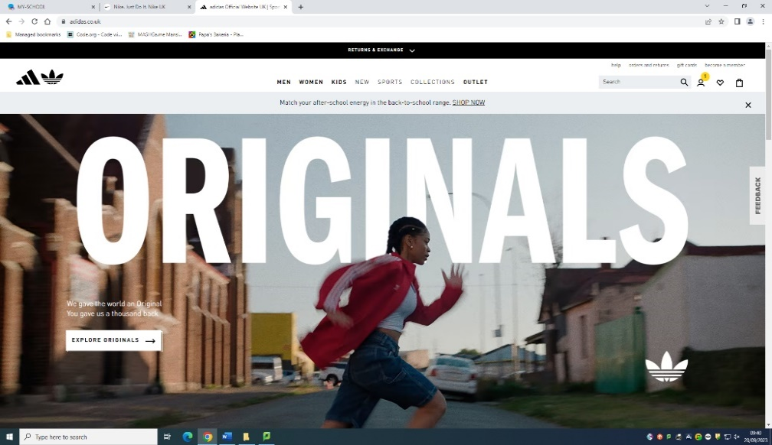

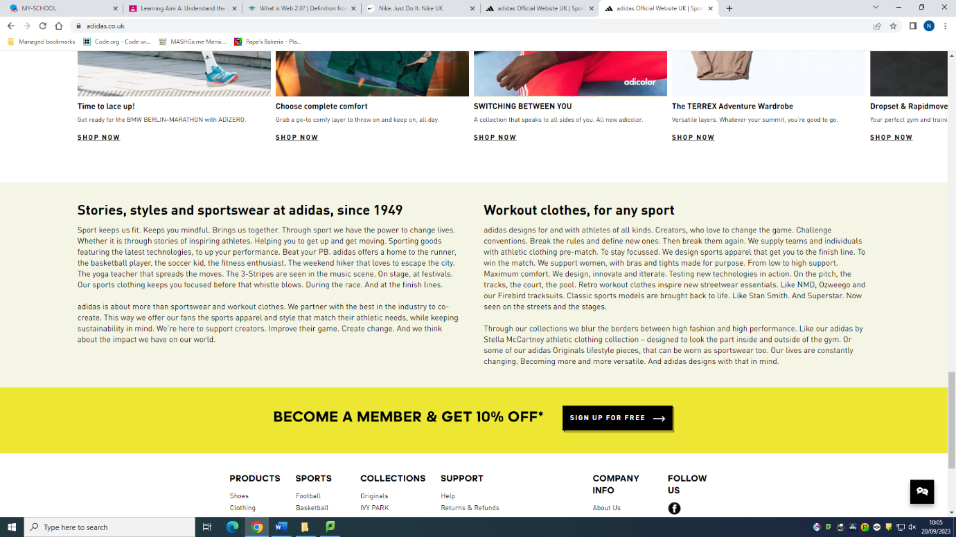

This is the symbol at the bottom right-hand corner used for getting into contact with Adidas.

**Purpose of web site design:**

* **Product and/or service based:** The Nike and Adidas website are both products based as they are both selling familiar products and just different brands.
* **Target audience:** Both Nike and Adidas are a website used for both genders female and male and it’s for buyers interested in getting sports branded clothing. Both websites are user friendly as they have a search bar at the top along with different categories to suit whatever the end-user what they may be looking for, but also if they have any queries they can scroll to the bottom and contact the customer service.
* **Principles of website design:**

**white space-** Both websites have a lot of white space but that is because it attracts the end-user’s attention.

**Accessibility-** Both websites are very accessible as when you hover over an image it will give you the name of what the product is and there are also videos of the newest products out.

**Accuracy-** Both websites are very accurate as both are being updated every day with new images of products and both are made sure that there are no spelling mistakes.

* **Media and objects:**

**Colour-** The colour of Nike main page is black and white but there is also a photo of the newest product out that is very big, and it has a variety of tones and colours. The Adidas website is very similar, it has 2 photos of the main page that are colourful.

**Size-** On the Nike page you will find a big photo of the latest product. On the Adidas page you will find 2 images first one being a woman running in the latest fashion shoes and the one below is a image of kids and it has 3 interactive buttons so if you press on one of the categories either men, women or kids it will take you to a page with them products.

The font is a sanserief font on both websites as this font does look more aesthetically pleasing.

* **Creativity and Innovation:**
* **Search engine optimisation:**

**Key words-** Nike website only has a few keywords on the homepage, on the categories and the title of the newest product out. On the other hand, Adidas has key words such as the categories and in the images.

**Importance of updates-** Both Nike and Adidas make sure to update their websites on a daily basis so when for example there is a product that went out of stock, they will need to update it on the websites, so the end-user doesn’t buy something that isn’t available.

**Media and Objectives:**

* **Proportion:**

The Nike website has a good proportion of the images and text as it has large photos and video at the home page followed by some text.

The Adidas website is very much similar with the layout of their website.

* **Colour:**

Nike website has used a variety of colours. The colours on the page are conservative and the focus is on a user clicking through on the actual products. Nike has stuck to their signature design as they have on the rest of the site. White background and plenty of white spaces combine with black typography.

On the other hand, Adidas uses a variety of colours for their products, but their logo is black and white which is the same as the Nike logo.

* **Size:**

The size of the Nike website varies as on the Nike home page their photos are quite big compared to Adidas as it has a big video on the main page followed by a large image and underneath there is small images of their newest fashion footwear.

* 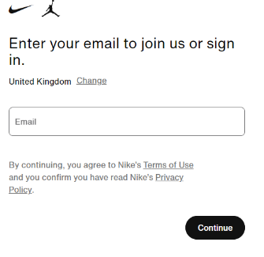**Appropriateness:**

With the Nike website there are social media logos at the bottom of their main page and when clicked into, it will take you to their social media page.

Nike has also included a sign-up page that you can create and account and get exclusive offers every so often. This would make a customer come back to shop again to get more products.

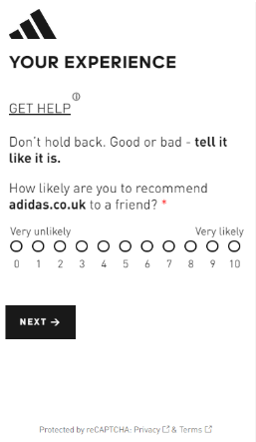The Adidas website has also got social media logos at the bottom of their page which the user can press into to go onto their social media page.

****The Adidas website has a feedback button at the right-hand side of their homepage so when pressed you can give Adidas feedback. This button is very accessible, and all users can get into it. The Nike website doesn’t have this feature and that’s what makes them different from each other.

**Creativity and innovation:**

Nike has an iconic slogan: “Just Do It.” They have put this famous slogan to the test to see how the company applies “Just Do It” to their website design and they were pleasantly surprised. Nike’s eCommerce website combines ease of use with a simple colour palette that everybody from teens to older adults can enjoy. The website uses snappy pages with animation to showcase its latest products.

Nike website design has instant colour preview on product grids. When hovered over an image lets you instantly see a smaller grid user the product. This secondary grid 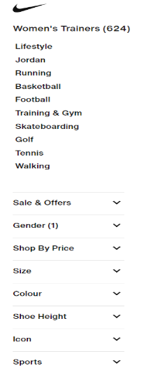gives you a look at products variations. Then you can see the available colour options and what the shoe looks like in different colours.

The white background and plenty of white space combine with black typography on the Nike website is a no-nonsense approach that makes it easy to examine with different products.

There are filters on the left sidebar show category statistics. On the left side you can see the products available as well as all the products in that category.

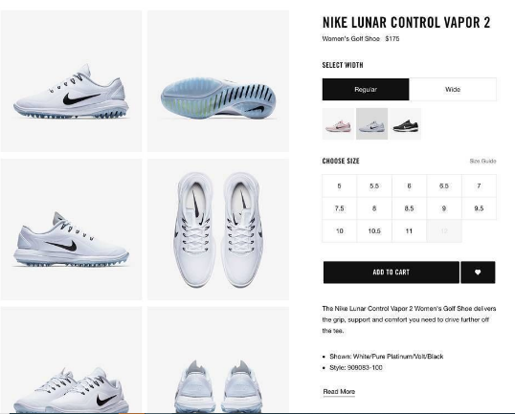The Nike website also includes design product videos meaning that it will take the users eye for the design making the user want to buy the product.

The Nike website product detail pages show more than 4 images. This helps the user to see the product in full detail meaning the customer is highly likely to buy the product.

The Adidas website is quite like the Nike website as it also has similar features just different layout.

For the Adidas website, also has white background and plenty of white space that is combined with black typography on the Adidas website. This what the users will want to look at because if the website was to have a lot of different bright colours, the end user would not want to look at it means they wouldn’t use it.

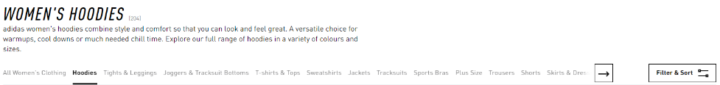Just like in the Nike website, Nike has got a similar layout but only Adidas has the sidebar at the top making it user friendly and easily accessible.

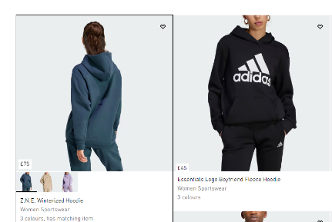The Adidas website has got an image of a product and when you hover over the image it will show you the back of the product as well as the different sizes it is available in.

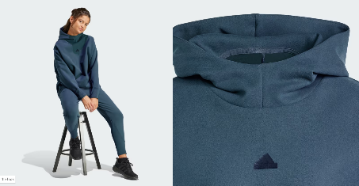When you click on a product you can see the product at different angles, and you can zoom in and out of the product. This is very helpful for a website to have so that the user that may not see that they can zoom in and out.

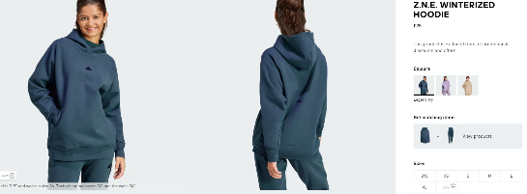



**Design a website to meet client requirements:**

**Problem Definition Statement Requirements:** A web Developer would need as much information about what the client wants their website to look like as possible. If the developer gets a lot of information that is relevant to the design of the website, the web developer will have very little corrections to make after the client has seen the website. In order to make the website Hot Beans Web you need to let the developer know what it is and information that would become handy for them.

**Intended Audience:** The client should let the Web Developer know how they want their website to look like as accurate as possible but also since the web developer is a person who does all the web designs, they should add things to the website and ask the client do they like it in a specific page as it may attract more customers into the website.

The web developer should also add attractive images to attract the customers eye for my website of Hot Beans Web and on one of the pages there may be people from Hot Beans web giving an insight of what they get up to during their day of work. The Hot Beans Web website should also include a interactive video that should be on the home page so it attracts the clients eye and makes them want to watch the video.

**Full summary of the problem to be solved:** As a web developer, I have been asked to create a Hot Beans Web website and include a profile of the company, profiles of existing trainee web developers, job specifications and required qualifications, an online application form along with links to web development courses. As a web developer, I had to create the application form but don’t know if it will be working ok for everyone to be able to access it so in order to find out I will be carrying out surveys and questionnaires to see if it works fine in all devices.

**Constraints:** I have been asked to make a website of Hot Beans web for my client and as a web developer there is constraints to create a web site and money may be a big one as some people have a budget on making a website as they may only be starting their business and may not have much money. Another constraint may be timescales as there may be a client wanting the website done within a short timescale and as a web developer you may be creating 2 websites at the same time meaning that it would be tight, and the website would have to be rushed.

**Benefits:** when a client approaches a web developer that wants to have a website in their business, it means they have done their research and they know that if they have a website in their business it will be advertised world-wide and is much cheaper to have a website than any other method of advertisement, but also it benefits the end users as they can get into the website at any day and any time and the end users will remember that this was the possible website to look back on again.

**Nature of interactivity: As a web developer I have to make sure that my website isn’t too basic by that meaning too many things on the 1 page which will make the end user come out of the page but also too much things on the page makes the end user overwhelmed**

**Storyboard:**

**Intermediate Course Website:**

https://www.pluralsight.com/browse/software-development/web-development?gclid=EAIaIQobChMI3a7C-dHb2wIVTbHtCh2gEwulEAAYASAAEgLuW_D_BwE&aid=701j0000001heIpAAI&promo=&oid=&utm_source=non_branded&utm_medium=digital_paid_search_google&utm_campaign=UK_Dynamic&utm_content=&s_kwcid=AL!5668!3!247632267241!b!!g!!&ef_id=WFEQsQAABSwyVs6E:20180617212759:s

**Advance Course Website:**

[Best Online Web Development Courses and Programs | edX](https://www.edx.org/learn/web-development)

**Beginner Course Website:**

[HTML5 + CSS3 + Bootstrap: The Beginner Web Design Course | Udemy](https://www.udemy.com/course/html-css-bootstrap-build-your-first-website-today/)

**Index:**

**Job Specifications/ Entry Requirements**

**Online Application Form**

**Web Development Courses**

**Existing Trainees**

**Obtaining and using feedback from others:**

|  |  |  |  |
| --- | --- | --- | --- |
| **Page:** | **Before:** | **After:** | **What has changed:** |
| Online Application form: |  |  | On this page my client didn’t like the way the boxes weren’t all the same sizes and has asked me to change it so they are all the same width. |
| Job Specification/ Entry Requirements: |  |  | On this page, my client has said that they want the writing at the top instead of centre and move the writing so that the bullet points are in a line. |

I had a meeting with my client and there are a few things that they have requested me to change which there wasn’t much and they were happy with the website. Whatever I had to fix, I have put in screenshot before and after of how the page looked like.

**Testing plan:**

We use a testing plan to check if all parts of the website that it works as it should be.

As a web developer, a test plan always needs to be carried out before the website gets published.

All the testing below was carried out in Microsoft edge and the corrective actions that don’t work in google chrome.

|  |  |  |  |  |  |
| --- | --- | --- | --- | --- | --- |
| **Test Number:** | **Purpose of test:** | **Page:** | **Test data:** | **Expected result:** | **Actual result/Screenshot:** |
| 1 | Test the video | Index Page | Click play | The video should load and work fine. | The video loaded and played fine when it was opened in Microsoft Edge. |
| 2 | Test the scrolling text | Index page | Automatically should scroll | The text should scroll at the top of the page | When you open the homepage the scroll text automatically scrolls. |
| 3 | Test to see if the hyperlink to other pages work | Index page | Press the word that is blue coloured | When pressed it should take you to the page | When the word is pressed on Microsoft Edge, it opens fine. |
| 4 | Check if the font on my website can be made smaller or bigger | Index page | At the bottom press smaller font or bigger font | When pressed it should make the font size on the page either bigger or smaller depending on what you press. | On Microsoft Edge, some words do not become smaller or bigger. |
| 5 | check the ‘back to top’ button to see if its working | Index page | At the bottom of the page press back to top | When button is pressed you should press the back to top was tested and the outcome should be page going back to the top. | when the back to top button is pressed, the page gets scrolled back to the top of the home page. |
| 6 | Check if the words are getting bigger or smaller when button is pressed but also check the ‘back to top’ button to see if it’s working. | Job specification/Entry Requirements page | At the bottom of the page either press smaller font or bigger font or press back to top | When either button is pressed you should either have the font bigger or smaller depending on what you pressed and if the back to top was tested the outcome should be page going back to top. | After the Smaller font or bigger font is pressed, your font will get bigger or smaller.  When back to top button is pressed, the page gets scrolled back to the top. |
| 7 | Check to see if the reset buttons are working. | Online application form page | After the application form there are 2 buttons reset form and submit form | When pressed the reset form after the details have been put in and you click reset it should reset the form and should go blank. | When the form has been filled in and the reset button is pressed the expected outcome is the form to reset and should go blank but when I filled the form in and opened it in Microsoft edge, the form doesn’t go blank. |
| 8 | Check to see if the submit buttons are working. | Online application form | After the application form there are 2 buttons reset and submit button on the form | When pressed the submit button on the form after the details have been put in and you click the submit button, it should submit the form by the form going blank. | Before the form being submitted:    After the form has been submitted:  After you press submit form, the form goes blank meaning that your form has been sent. |
| 9 | Check to see if the map opens | Online application form page | When the website is opened in Microsoft edge it should open fine | When you go into the Online application form page and scroll to the bottom there should be a map. | when the website gets opened on Microsoft edge, the map opened and can be scrolled. |
| 10 | Check if words are getting bigger or smaller when button is pressed | Online application form page | At the bottom of the page either press smaller font or bigger font | When either button is pressed you should either have the font bigger or smaller depending on what button is pressed. | After the smaller font or bigger font will be pressed, not all words go bigger or smaller depending on what button is pressed. |
| 11 | Scrolling images | Web courses page | Open the web courses page | When you open the web courses page on Microsoft edge the images should be scrolling. | when the page gets opened on Microsoft Edge, the images are scrolling on the page and they opened fine. |
| 12 | Link to a beginner’s course | Web courses page | Open the web courses page and click on beginner course. | When you press the beginner course, it should take you to a website. | when the link is pressed, the page opened and it worked fine. |
| 13 | Link to an intermediate course. | Web courses page | Open the web course page and click on intermediate course. | When you press the intermediate course, it should take you to a website with more information and the course itself. | When the link is pressed, the page opened and worked fine by opening it from Microsoft Edge. |
| 14 | Link to an advance course | Web courses page | Open the web courses page and click on the advance course. | When you click on the advance course, it should take you to a website with more information and how to complete the course. | When the link is pressed, the page opened and worked fine by opening if from Microsoft Edge. |
| 15 | Test to see if the hyperlink to another page is working | Web courses page | Press the word that is coloured in blue | When the work is pressed it should take you to a different page on the website. | when the word is pressed it takes you directly to the online application form. |
| 16 | Check if words are getting bigger or smaller when button is pressed | Web courses page | At the bottom of the page either press smaller font or bigger font | When either button is pressed you should either have the font bigger or smaller depending on what button is pressed. | After the bigger font or smaller font have been pressed by opening it through the Microsoft Edge, the words in bold will only chnge to be either bigger or smaller. |
| 17 | The Facebook logo at the bottom of the page | All pages | At the bottom there of the page there is a Facebook logo, you need to click on it. | When the Facebook logo is pressed, you should be directed to our Facebook page. | After you press the facebook logo on any of the pages at the bottom, you will be directed to our Hot Beans Web facebook page. |
| 18 | The Twitter logo at the bottom of the page | All pages | At the bottom of each page there is a Twitter logo, you need to click on it. | When you click the Twitter logo, you should be directed to our twitter page. | After when you pressed the twitter logo, you have got onto our twitter page. |
| 19 | The TikTok logo at the bottom of all pages | All Pages | At the bottom of each page there is a TikTok logo, you need to click on it. | When you click on the TikTok logo, you will be directed to our TikTok account. | Social Video App TikTok Has Been Banned In These Stateswhen you press the TikTok logo on our page, you will be directed to our Tiktok account. |
| 20 | The Instagram logo at the bottom of all pages. | All pages | At the bottom of each page there is a Instagram logo, you need to click on it. | When you click on the Instagram logo, you will be directed to our Instagram page. | Instagram Engagement: Everything You Need to Know [Exclusive Stats]  When you press the Instagram logo at the bottom of our website, you will be directed to our Hot Beans Web Instagram page. |

|  |  |  |  |  |  |  |  |
| --- | --- | --- | --- | --- | --- | --- | --- |
| **Test Number:** | **Purpose of test:** | **Page:** | **Test data:** | **Expected result:** | **Actual result/Screenshot:** | **Screenshot of Google chrome:** | **screens** |
| 1 | Check if the font on the page is getting bigger or smaller. | All pages | At the bottom of the index page there is 2 buttons, smaller font and bigger font | When you press either button, your font should either become bigger or smaller depending on what button you press. | When it is opened on google chrome on every page it does work fine and makes your font size either bigger or smaller. |  |  |
| 2 | Check to see if the reset button is working. | Online application form | When you fill out either of the application forms, and you messed the details up, there is a reset button. | When you messed up your form and want to quickly delete the detail press the reset button and it should clear your form | When the form is being filled out and the website is opened from google chrome, the form does reset and work meaning you can start filling out your form again. |  |  |

The table below shows the things that don’t work on Microsoft Edge but work on Google Chrome:

**Bibliography:**

* How to save your movie out from Moviemaker:

<https://moviemaker.minitool.com/moviemaker/save-movie-maker-project.html>

Date Accessed: 12/09/2023.

* What makes a good website:

<https://www.ideasonpurpose.com/on/7-qualities-great-website/#:~:text=So%20it's%20important%20to%20be,quickly%2C%20correctly%20and%20as%20expected>.

Date Accessed: 14/09/2023.

* How to use photoshop:

<https://blog.hubspot.com/marketing/how-to-use-photoshop>

Date Accessed: 18/09/2023.

* How to hyperlink on Microsoft Web Expression.

<https://www.tutorialspoint.com/microsoft_expression_web/microsoft_expression_web_hyperlinks.htm>

Date Accessed: 22/09/2023.

* How to create a contact form on Microsoft Web Expression.

<https://www.thesitewizard.com/expression-web/expression-web-4-tutorial-9.shtml>

Date Accessed: 2/10/2023.

* Dynamic drive Document text sizer.

<http://www.dynamicdrive.com/dynamicindex9/textsizer.htm>

Date Accessed: 9/10/2023.

* Dynamic drive back to top button.

<http://www.dynamicdrive.com/dynamicindex3/scrolltop.htm>

Date Accessed: 12/10/2023.

* How to hyperlink the social media logos to existing social media pages:

<https://www.tutorialspoint.com/microsoft_expression_web/microsoft_expression_web_hyperlinks.htm>

Date Accessed: 16/10/2023.

* How to add a map into Microsoft Web Expression:

<https://www.imapbuilder.com/interactive-map-online/userguide/embed_your_interactive_map_into_microsoft_expression_web.php#:~:text=Run%20Microsoft%20Expression%20Web%2C%20open,with%20the%20interactive%20map%20inserted>.

Date Accessed: 18/10/2023.

* How to add submit and reset buttons on Microsoft web expression:

<https://www.dotnetcurry.com/ShowArticle.aspx?ID=300>

Date Accessed: 20/10/2023.

* How to add the scroll image marquee:

<https://www.angelfire.com/nm/thehtmlsource/jazzup/text/marqueeimage.html>

Date Accessed: 23/10/2023.

* Changing a PNG file into a JPG

<https://png2jpg.com/>

Date Accessed: 29.01.2024.

**Test Plan:**

**My Code:**

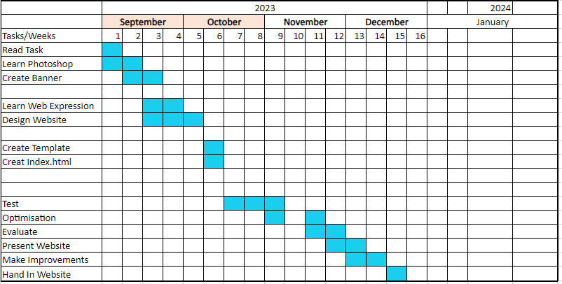**Gant Chart:**

**Evaluation:**

The Task I was set to complete was to create a professional multimedia package for Hot Beans web. Prior to starting my own website, I have looked through different websites for layouts and what others have put into their website. This gave me a lot of ideas and I knew what looked nice on the pages and what didn’t.

**Suitability for intended purpose and audience:**

The multimedia package must include an original animation, video and logo designed for the Hot beans Website.

The package should contain 5 pages and should contain Hot Beans Web information about the following:

* Home Page
* Existing Trainees
* Job Specifications/Entry Requirements
* Online Application Form
* Web development Courses.

I was also told to complete a website that was accessible enough for all users but also include some images and a video.

I have met the user requirements, and this is because I have completed all five pages. All 5 have the exact same font and I have inserted accessibility buttons at the bottom of each page. I have made sure that I have enough white space on each of my pages but also not too much.

1: The following screenshots below show all the items I was aiming to put into the website.

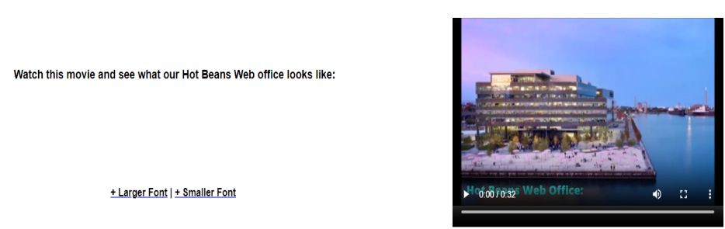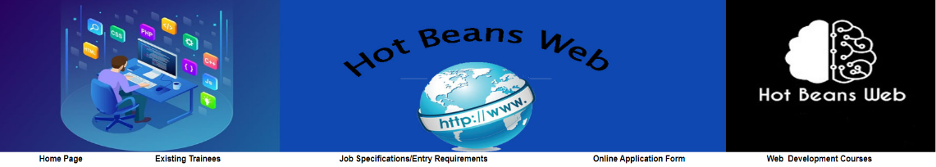2: On this screenshot, we can see that I have created all 5 web pages that are all hyperlinked.



3: At the bottom of the index page, I have a video and the accessible buttons for accessibility.

On each of the page you will find accessible buttons at the bottom, this is an example of the existing trainee’s page.

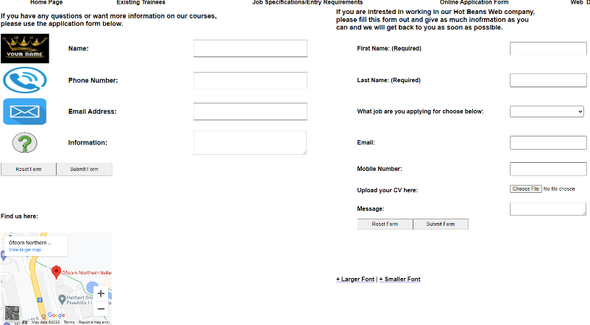

4: I was also asked to include and application form on some page of my website along with a map.

I have met this user requirement and have made 2 different application form along with a map at the bottom of this page.



5: On my web courses page, I have made sure to add some scrolling images as my client wanted to have some sort of images on some sort of page.

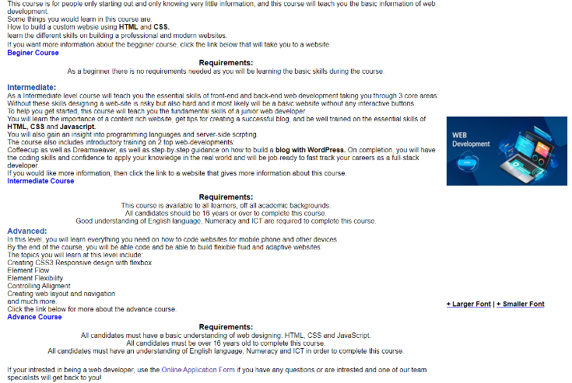

6: For the last page I was also told to hyperlink my website to other web pages. I have met this user requirement as I have hyperlinked my web pages to 3 different websites so when the user presses the words in blue, they will be directed to a web site that will give them more information about their course.

**Quality in comparison with another similar website:**

I have looked at many different websites and I had my eye on one that had a nice and attractive layout. So, I have decided to use this layout and put in my own description. I have also really liked the way this person has hyperlinked their page to other pages on their website. The one on the left is the developers from the internet and the one on the right is mine.

I also didn’t really know what to create my movie on, so I went online and have searched different websites and looked on what they have made their movie on and I have decided to make a movie on the office tour showing the luxury the Hot Beans Web employees have.

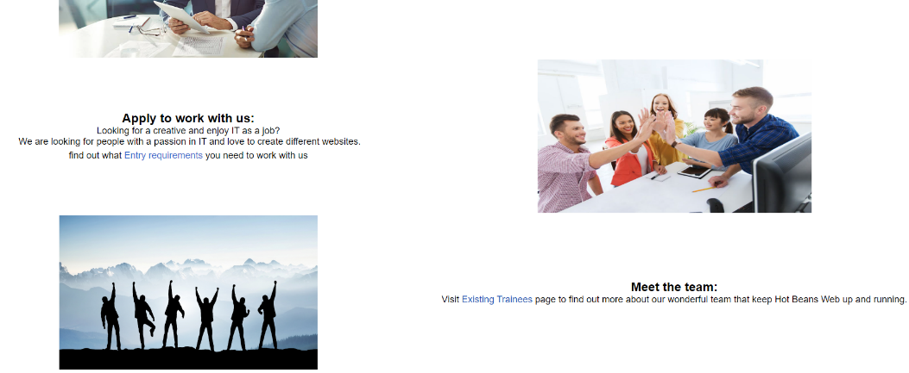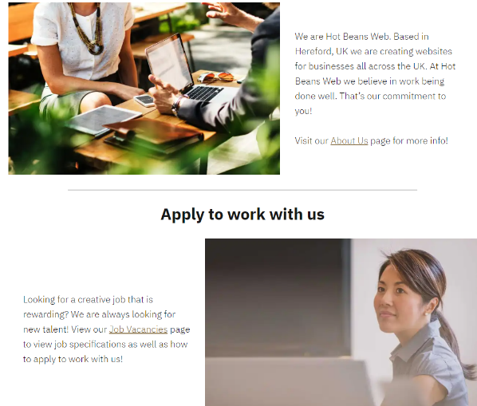

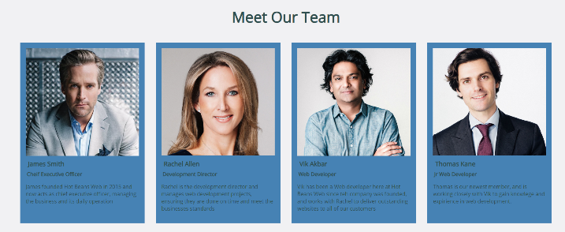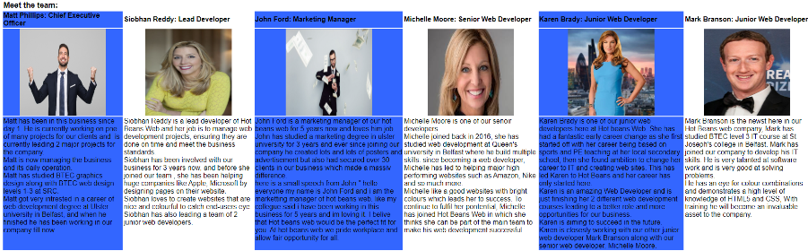The image of the left is a screenshot I have took from a different website and this is because I really liked the layout, they have on their home page and, they have hyperlinked their home page to other pages on their website. So, this is why I have decided to do the same website but change the wording.

For the existing trainees, I have seen different website and this one website has sticked out to me, so I have decided to do a similar page.

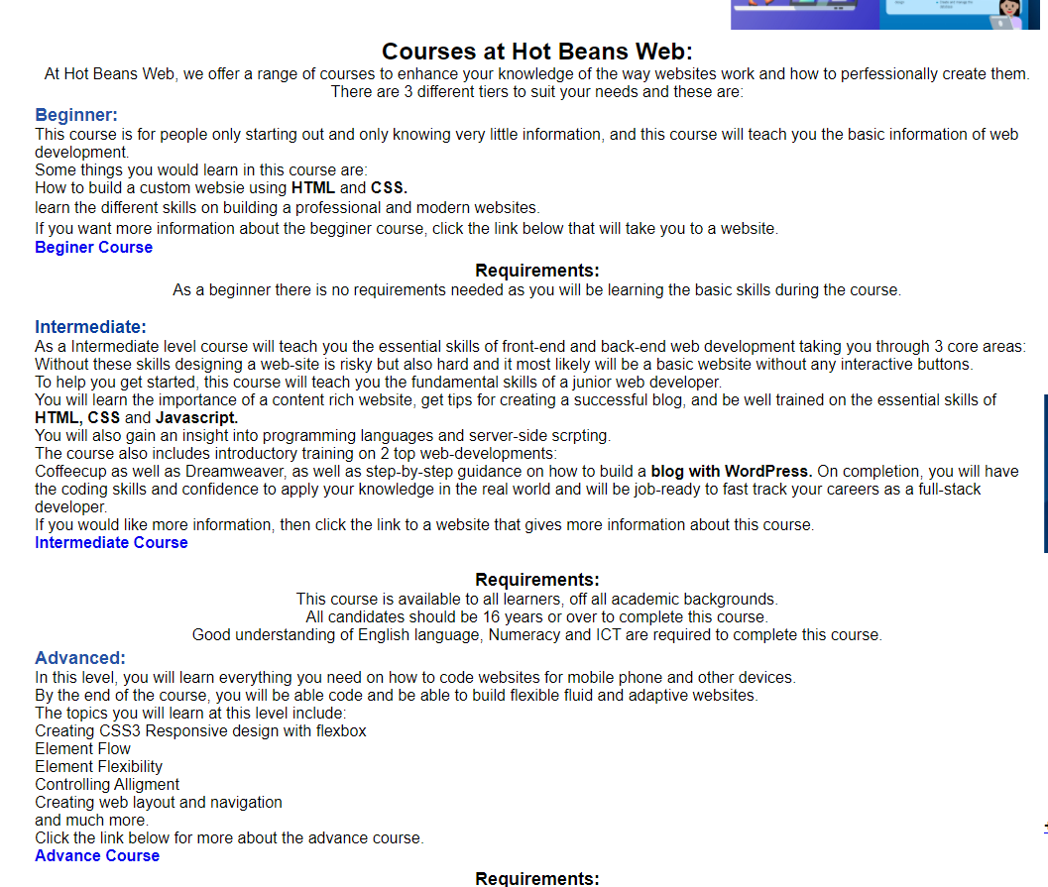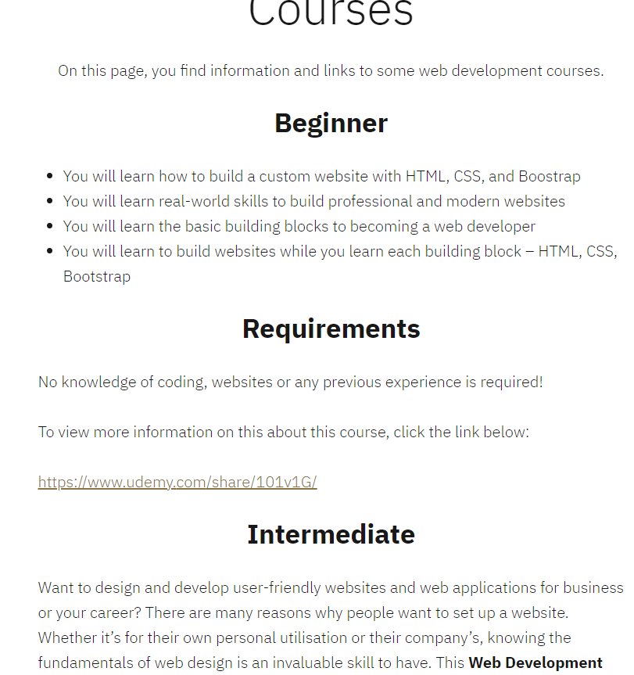

For the last page I have seen this one website that has caught my eye and I wanted to have a similar layout so that it will catch users’ eye on my website, so I have added links to different web pages that are specific to the 3 levels for web courses.

**Feedback Received:**

For the feedback I have been provided from my client and overall, they were very impressed with my website, and they wanted very little to change.

I have also gathered feedback by creating a google form and asked people to look at it and provide feedback so then I can see what final things need changed but also if something isn’t working to get it fixed.

**Strengths, Weaknesses and improvements:**

* I have managed to complete the website and include accessibility buttons.
* I have managed to add in a scroll marquee to my homepage, so it looks more attractive and eye catching.
* I have also made sure to hyperlink part of my website to other web pages on my website.
* At first my video I have uploaded onto my website didn’t want to work but then I had to change something in the code.
* On my last page, it was very much basic fully filled with information and I asked my client what else can I put into it so it looks a bit more eye catching and so we have come up with an idea to add scrolling images at the top of the page.
* I had to improve on my last page as it was very much basic filled with a lot of information, so I have decided to add images that were scrolling on the page which gave it a little bit more of aesthetics.

Legal and ethical considerations:

As a web developer there are 2 things to consider when designing and developing websites.

* Copyright, design and patents act 1988:

This act protects all original works that people have created when they are in a fixed form they can be released or published.

The original work is the intellectual property of the individual who has created it.

* Data protection act 1998:

This act was set up to protect sensitive data held in a database. Hot Beans web must store any data about the applicant that are applying for hot beans web, information like the applicant’s exam grades, their background information and any other personal information.

The web designer should also consider how the data protection act could affect their website, like our Hot beans web website that collects information about the applicant that is applying for Hot Beans web information includes the applicant’s personal information, this form should include a privacy policy that informs the applicant how you retain, process, disclose and purge their data in line with the act.

I have created my own banner for the Hot Beans website with just using the images that I have found on google images.

Website review:

Quality in comparison with other similar websites:

Once I have completed my client’s website, I will compare the website against a similar themed website. By doing this it will help me find out what I can add to make it stand out from the other existing websites. There will be websites out already which are better than mine, but this is how I can improve the website adding strong features from similar websites. By doing this, it will help me to produce a website which will stand up to competition from similar websites.

Suitability for intended purpose and audience:

My website will need to be reviewed to establish whether it is suitable for the purpose and audience for which it was intended. Quite often it will involve carrying out some form of market research to get feedback from potential users and discussions with the client to see if they are satisfied with the overall website. I am fully aware that my client may not like the website and may ask to change a few things about it and that’s ok.

Suitability against the client requirements:

During the beginning of the website development lifecycle, one of the first elements to be generated was a list of requirements. These SMART requirements state what the website must be able to do and how it should work. In order to know if the website development has been successful, it is important for me to compare the original requirements against the final developed website.

Legal and ethical constraints:

As a web developer the website must be reviewed to ensure that it complies with any legal and ethical considerations. There are 2 things to consider when designing and developing websites.

* Copyright, design and patents act 1988:

This act protects all original works that people have created when they are in a fixed form they can be released or published.

The original work is the intellectual property of the individual who has created it.

* Data protection act 1998:

This act was set up to protect sensitive data held in a database. Hot Beans web must store any data about the applicant that are applying for hot beans web, information like the applicant’s exam grades, their background information and any other personal information.

The web designer should also consider how the data protection act could affect their website, like our Hot beans web website that collects information about the applicant that is applying for Hot Beans web information includes the applicant’s personal information, this form should include a privacy policy that informs the applicant how you retain, process, disclose and purge their data in line with the act.

I have created my own banner for the Hot Beans website with just using the images that I have found on google images.

**Moodboard:**

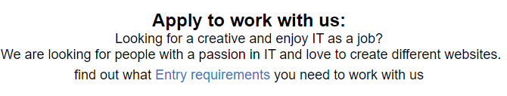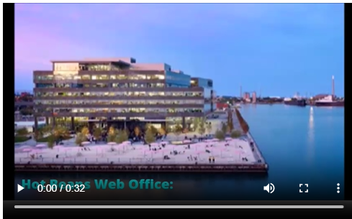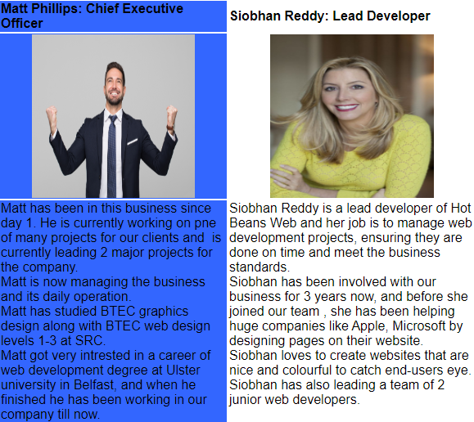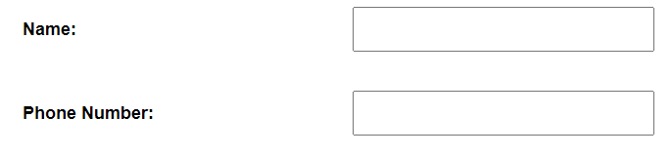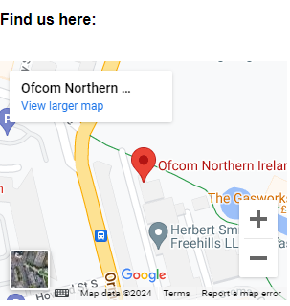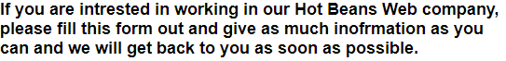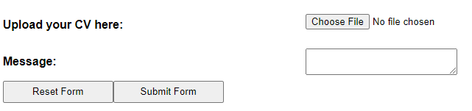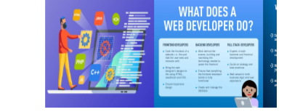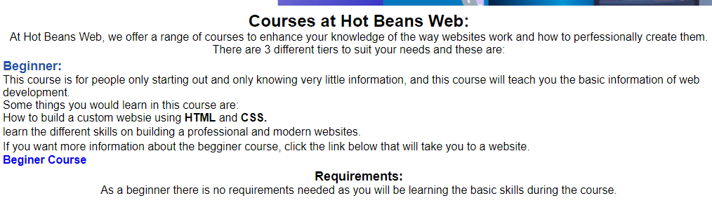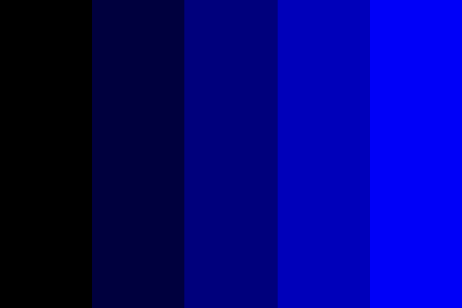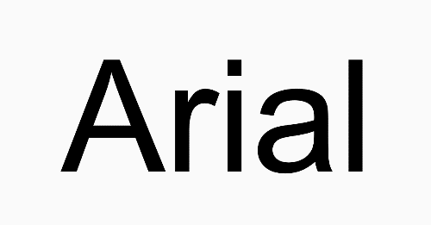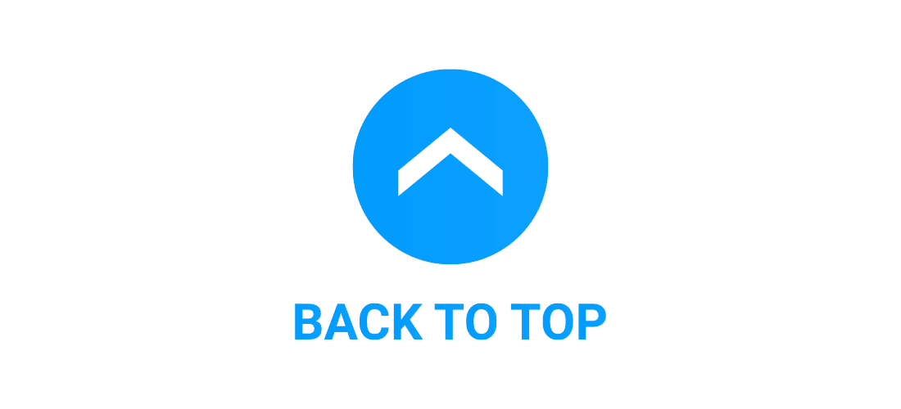

**Feedback from Moodboard:**

I have met and discussed with my client about what opinions do they have of all the ideas that are on the moodboard. Firstly, I wanted to discuss the colour scheme on the website, my client said they really like the colours as they all go together, and the colour blue is the colour of the ocean and sky, and it symbolizes stability, inspiration, freedom and imagination. The colour blue can be a calming colour.

The other colours I have used were black and white and this is because the colour blue goes well with black and white. The colour black symbolises elegance, wealth and power. The colour black it also better to look at as its not as bright as every other colour.

The colour white symbolizes purity, cleanliness and innocence which creates a sense of space but also adds highlights and this is what end users like to see.

The font I have decided to create the website is arial this is because it can be used with equal success for text setting in a website. Arial contains more humanist characteristics than many of its predecessors and as such is more in tune with the mood of the last decades of the twentieth century. The arial font is mostly used in presentations and advertise and promote the website.

I have made sure to create a website that was accessible to all users. This means I have added a large and small font that the user can change to suit their needs. The purpose of having buttons to change the font style to make it bigger is to make it easier for users with visual impairments to read content. Increasing font size can help individuals with low vision or age-related eye conditions access information more easily.

The website also has scroll marquee on two pages, one is text scrolling and the other one is a photo marquee. By adding scroll marquee, is a great option for adding visual flair to your text, drawing end user’s eyes to important information.

I have made sure to use white space as it helps to balance the page’s design, organize the content and elements, and improve the visual experience for the user.

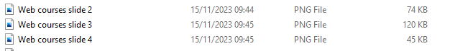Pre optimisation: Page 373

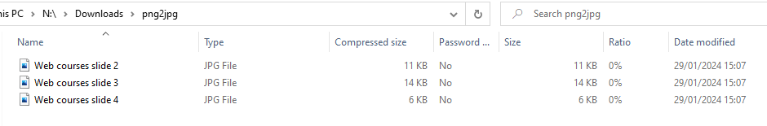Post Optimisation:

The result of the optimisation is that it has decreased meaning that the download has increased. Adjust the image quality as needed. PNG uses lossless compression, meaning it preserves all the original data of an image without losing any quality. However, this can result in larger file sizes. JPEG uses lossy compression, which means that some of the original data is lost during the compression process.